

**Fitness and Lifestyle Documentation**

**(Template báo cáo cho các nhóm)**

| **Avengers<Tên nhóm>** | |
| --- | --- |
| **Group Member** | Nguyễn Phương Anh (Leader)  Trương Gia Bình  Nguyễn Thành Nam  Trương Đình Anh |
| **Center** | ACE-HANOI-2-FPT |

- Hanoi, 8/2023 -

**Table of Contents**

**1.** **Problem Definition 3**

i. Introduction 3

ii. Implementation Environment 3

**User Stories 4**

1.2 User type 1 (Example: Admin) 4

i. Story 1 4

ii. Story 2 4

iii. Story 3 4

iv. … 4

1.3 User type 2 (Example: Staff) 4

i. Story 1 4

ii. Story 2 4

iii. … 4

1.4 User type 3 (Example: Customer) 4

i. Story 1 4

ii. Story 2 4

iii. Story 3 4

iv. …

**2**[**. Use Case 6**](https://docs.google.com/document/d/1BqdS-eteOSuVxmBdmryPj17peh2B6gm0/edit#heading=h.1t3h5sf)

2.1 Search Products 6

2.2 Purchase Products

2.3…

**3. Flow Chart**

3.1 Search Products 6

3.2 Purchase Products

3.3…

**4****.** **Database(Chỉ category 2,3) 5**

4.1 DB Relationship Diagram 5

4.2 Table 1 (Example: Account) 5

4.3 Table 2 (Example: Category) 6

4.4 Table 3 (Example: Product) 6

**5****.** **UI\UX 7**

3.1 GUI 1 (Example: Login Form) 7

3.2 GUI 2 (Example: Address Book Form) 7

3.3 GUI 3 8

3.4 … 8

3.5 … 9

3.6 … 9

3.7 ... 9

3.8 ... 9

3.9 ... 9

3.10 ... 9

3.11 ... 9

4. Summary 10

# **Problem Definition**

### Introduction

….

### Implementation Environment

….

# **User Stories**

## **User type 1** (Example: Admin)

### Story 1

### Story 2

### Story 3

### …

## **User type 2** (Example: Staff)

### Story 1

### Story 2

### …

## **User type 3** (Example: Customer)

### Story 1

### Story 2

### Story 3

### …

## **…**

## **…**

## **...**

## **...**

# 

# Use Case

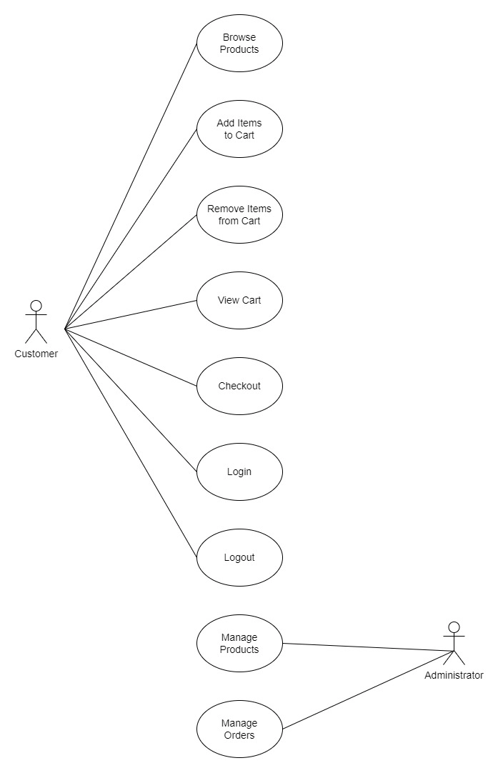

# Flowchart

* 1. 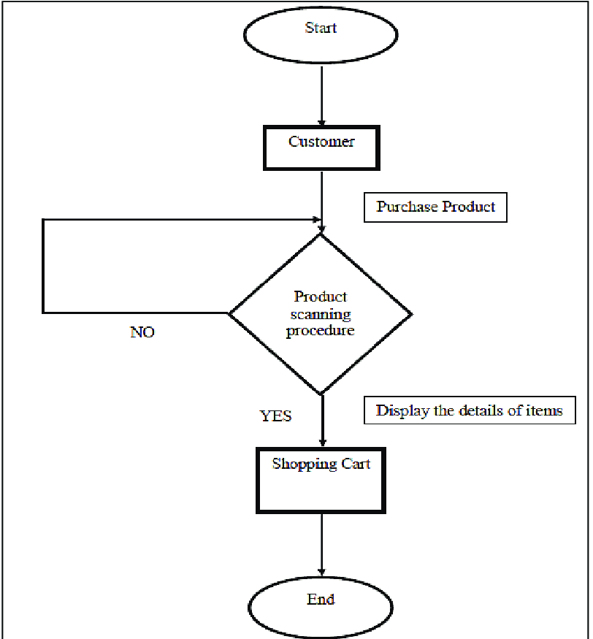

# Database

## **DB Relationship Diagram**

Example:

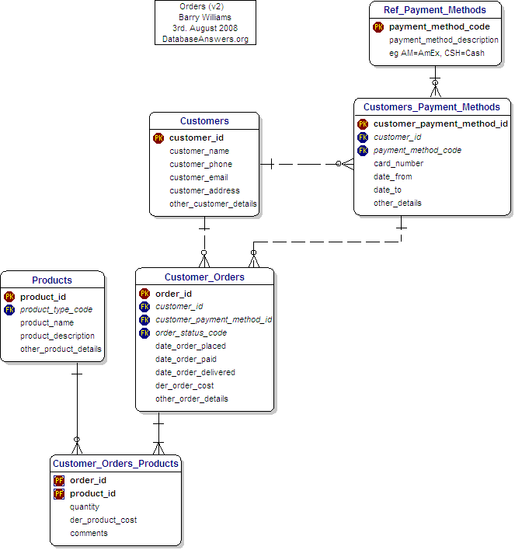

## **Table 1** (Example: Account)

| **Column Name** | **Data Type** | **Constraint** | **Description** |
| --- | --- | --- | --- |
|  |  |  |  |
|  |  |  |  |
|  |  |  |  |

Example:

| **Column Name** | **Data Type** | **Constraint** | **Description** |
| --- | --- | --- | --- |
| AccountID | int | PK | Primary key of the table |
| Username | varchar(30) | Unique | User name, to identify a account |
| Password | varchar(40) | Not null |  |
| LastLogin | Datetime |  | This is the time that the user last logged into the system. |
| Status | char(1) | Default(‘D’) | Status of the account (Disable, Active, …) |

## **Table 2** (Example: Category)

## **Table 3** (Example: Product)

## **…**

## **…**

## **...**

## **...**

# **UI\UX**

## **GUI 1** (Example: Login Form)

Example 1:

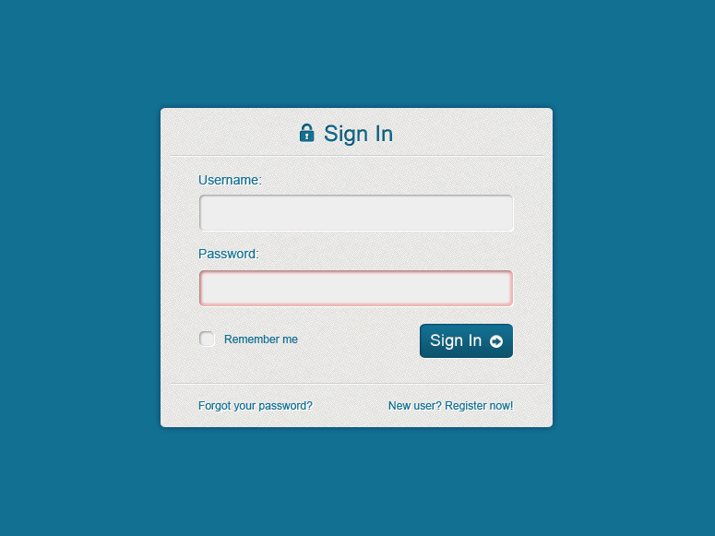

Example 2 (Mock UI):

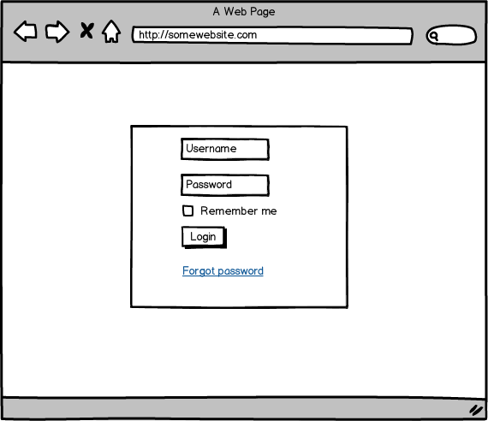

## **GUI 2** (Example: Address Book Form)

Example 1:

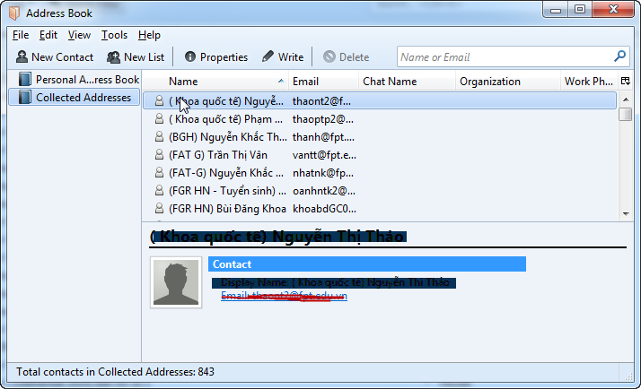

Example 2 (Mock UI):

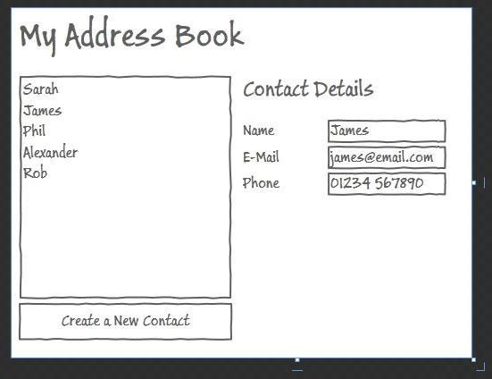

## **GUI 3**

## **…**

## **…**

## **…**

## **...**

## **...**

## **...**

## **...**

## **...**

# **Summary**